Scripting task:

Shell script that makes a curl to guvi.in and gets the return code and prints it.

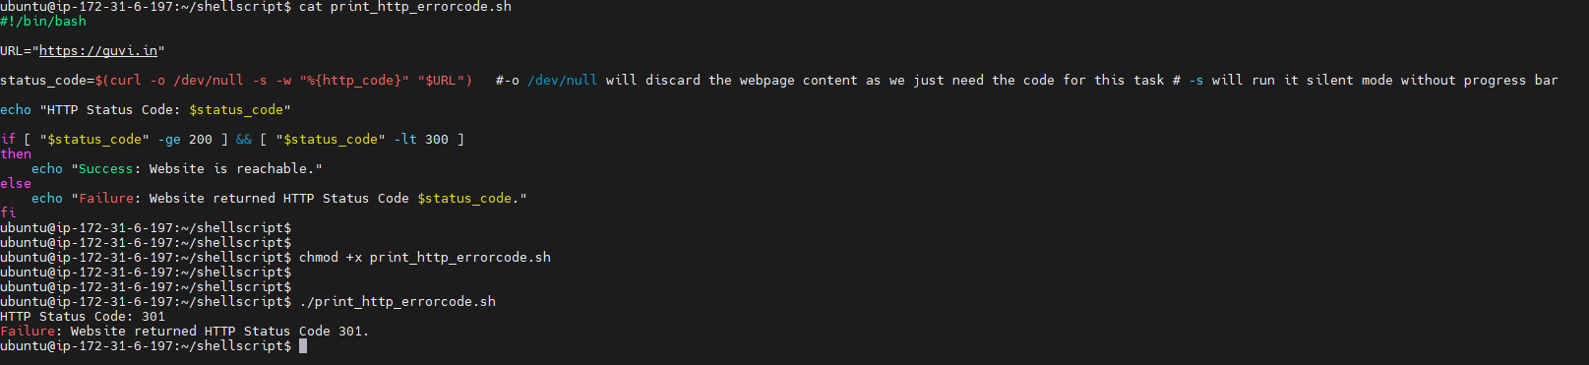

Replace give with learning when there’s welcome in the line script:
Given.txt file created with content:
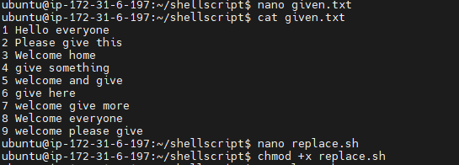

Script executed and replaced all the give with learning where the line have welcome in it:
